Case Study :3 — Hospital Billing and Patient Classification
- Problem statement
Develop a Python program to calculate a patient's hospital bill and classify it based on the total amount.
2. Objectives
Calculate total hospital charges.
Classify the bill using conditional statements.
3. Assumptions
All charges are non-negative.
The classification thresholds are defined by the programmer.
4. Algorithm
- Start.
- Read the patient name and charges.
- Add all charges.
- Use if-elif-else to determine the category.
- Display the bill and category.
- Stop.
5. Flowchart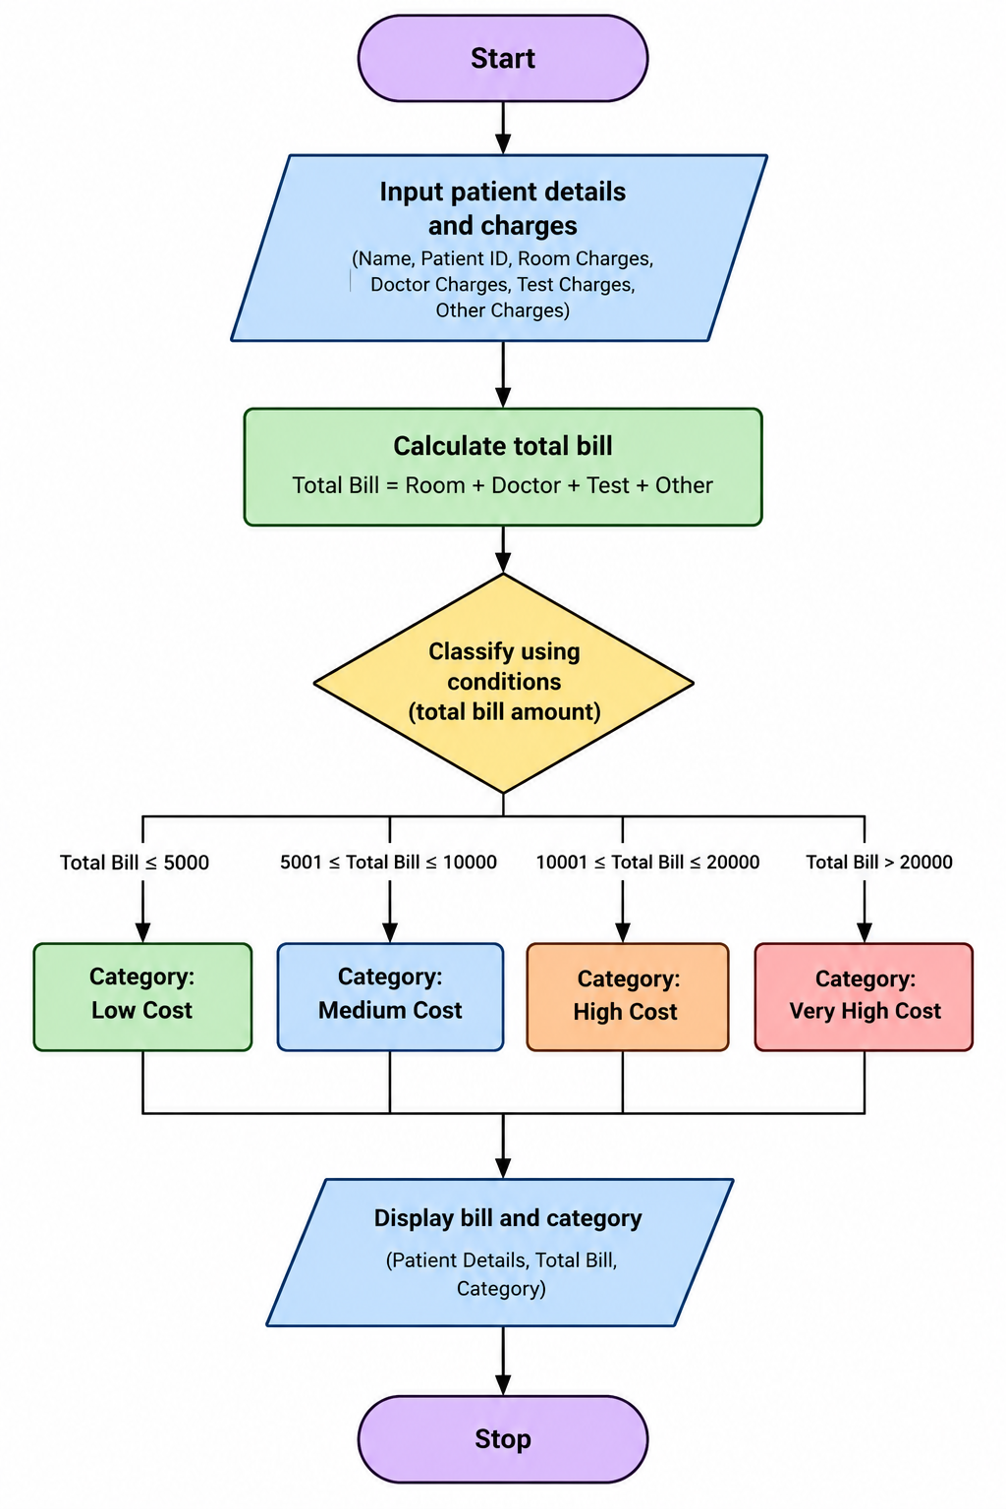
6. Pseudocode
START
INPUT name and charges
total = sum of charges
IF total < 2000
category = Low
ELSE IF total < 5000
category = Medium
ELSE
category = High
DISPLAY total and category
STOP
7. Test cases
Total charges | Expected category
Rs. 1500 | Low
Rs. 3700 | Medium
Rs. 6000 | High
- output
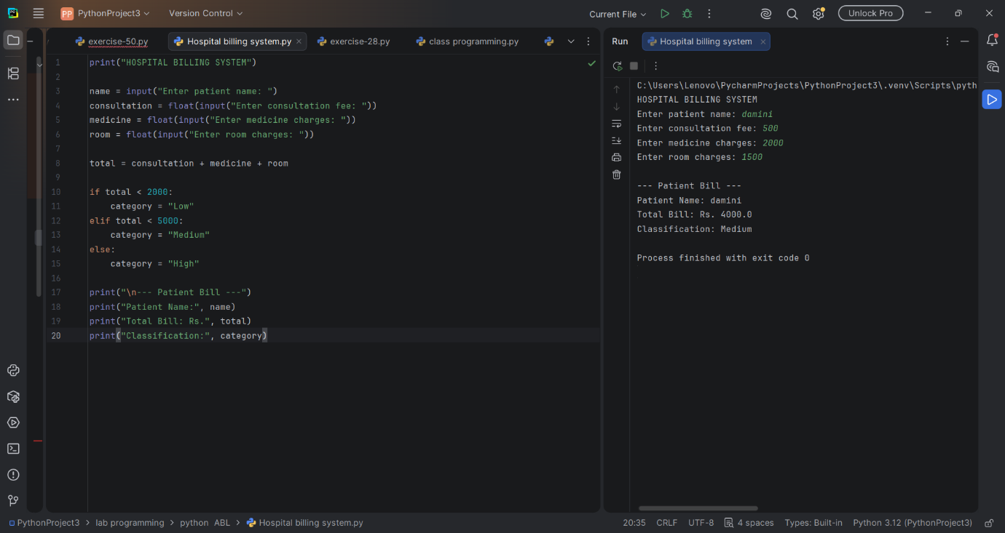
Include your Python code and the actual screenshot captured when running it.
9. Conclusion
The program calculates the total hospital bill and classifies it according to the defined conditions.

